Module 5: Ansible Assignment – 3
Tasks To Be Performed:
1. Create 2 Ansible roles
2. Install Apache2 on slave1 using one role and NGINX on slave2 using the
other role
3. Above should be implemented using different Ansible roles

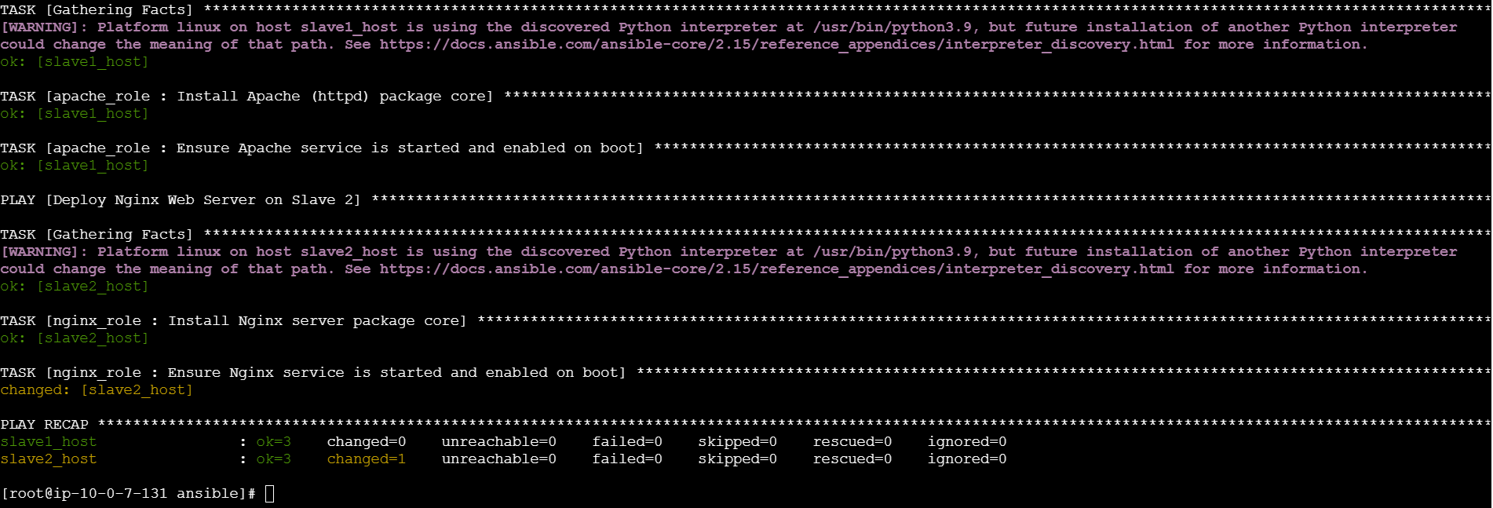
---
# Assignment Target 1: Deploy Apache role onto Slave 1
- name: Deploy Apache Web Server on Slave 1
hosts: slave1
become: true
roles:
- apache_role

# Assignment Target 2: Deploy Nginx role onto Slave 2
- name: Deploy Nginx Web Server on Slave 2
hosts: slave2
become: true
roles:
- nginx_role

